Pregnant? . . .
Are you or someone you know pregnant – a friend, daughter, sister, classmate, coworker, teammate?

You have REAL CHOICES.

No woman need choose abortion.
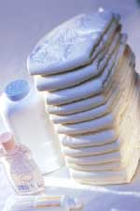
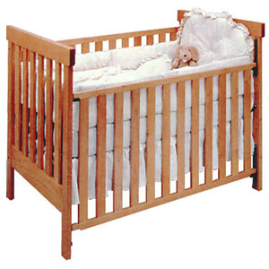
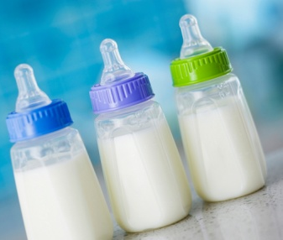
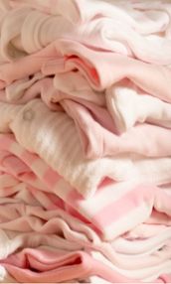
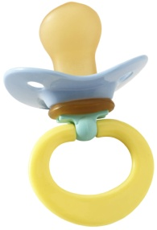
We can help.
Local pregnancy centers offer* FREE pregnancy tests, sonograms, STD testing, maternity clothes, confidential counseling, clothes for your baby, diapers, wipes, and supplies, cribs and mattresses, baby formula, housing, parenting classes, transportation, prenatal vitamins, referrals, post-abortion grief counseling. * Services and supplies vary by center.
Information about your local pregnancy resource center
(information available at www.realchoicesmaryland.org).

www.realchoicesmaryland.org • www.gabrielnetwork.org

Think You're Pregnant? Don't panic. Life is not over. There are so many decisions to make and questions to answer. Those around you might want things "back to normal.” And you might think it would be great to just be "not pregnant" again. But the truth is that nothing will ever change the fact that you were pregnant.

Don't cheat yourself. Rushing into an important decision that you will have to live with is usually not smart. First, put aside your fears and worries.

Support is available. You’re not alone. We can support you every step of the way, without judging you or telling you what to do. We're committed to providing compassionate and practical support and alternatives-to-abortion.

Whatever you need---there is help. Maybe you want someone with you to tell your parents or boyfriend. Maybe someone can help you stay in school or get a job, or help you find baby supplies. Whatever you need, we'll be there.

For tips on how to talk to your parents and tell your boyfriend or spouse, please visit http://www.realalternatives.org/pregnant/wecanhelp.htm.

The age of an unborn child (gestational age) is measured in two different ways – from the day of conception (when you actually became pregnant) and from the 1st day of your last menstrual period (practicing doctors usually use this date). The development of the unborn child is described below from the day of conception.

Day 1: Sperm joins with the egg, or ovum, to form one cell smaller than a grain of salt. Twenty-three chromosomes from each parent join to form every detail of human development: sex, hair, eye color, height, skin tone, personality, etc. If development continues normally, a baby will be born in 38 weeks.

Days 3-4: Travelling down the fallopian tube to the uterus, cells of this newly-created human are rapidly dividing.

Days 5-9: This tiny boy or girl implants in the soft lining of the uterus and begins to draw nourishment.

Days 10-14, Week 2: Some cells split off to become the placenta, which provides nourishment for the unborn child.

Day 20, Week 3: The unborn child is now the size of an apple seed. The placenta and umbilical cord are now functioning. The foundations for the brain, spinal cord and nervous system are established.

Day 21, Week 3: The heart begins to beat.

Week 4: Backbone and muscles are forming. Arms, legs, eyes and ears begin to show. Hair begins to sprout.

It is usually during this time a woman first discovers she is pregnant.

Day 30, Week 4: The unborn child is 10,000 times larger than the original fertilized egg. The heart is pumping increasing quantities of blood through the circulatory system. The placenta forms a unique barrier that keeps the mother's blood separate while allowing food and oxygen to pass through to the child.

Day 35, Week 5: Five fingers can be seen in the hand. The unborn child is now the size of a raspberry.

Day 40, Week 5: Brain waves can be detected and recorded.

Week 7: The uterus is about the size of a tennis ball. The unborn child is moving continuously. The jaw forms, including teeth buds in the gums. The eyelids seal to protect the child's developing light-sensitive eyes.

Week 8: Now a little more than an inch long, the unborn child has everything found in a fully developed adult. Forty muscle sets operate in conjunction with the nervous system and the fetus responds to touch.

Week 9: Fingerprints are already evident in the skin. The unborn child will curve its fingers around an object placed in its palm. The child weighs about 1/2 ounce and is developing fingernails and hair.

Week 10: The unborn child can stretch, make fists, open its hands, lift its head, squint and wrinkle its forehead.

Week 12: The unborn child now breathes amniotic fluid, sleeps, awakens, exercises, turns its head, curls its toes, and opens and closes its mouth.

